birendra singh
birendrabpl@gmail.com
Abstract
Project document contains the functional scope, interfaces and architecture diagrams
Stock Analysis App
Project book

Contents
Project architecture at a glance 2
Detailed architecture 7
1. System Context Diagram 7
2. Architecture / service diagram 8
3. Sequence / data flow diagram 8
4. Database ERD diagram 9
5. Algorithm diagram 11
6. API integration diagram 12
7. Component hierarchy diagram 12

I’m reviewing the project structure and the key React files so I can map the architecture and describe how the app works end to end.

Project architecture at a glance
This is a small React stock-analysis dashboard app with two views:
- a legacy dashboard for comparing quarterly stock performance
- a newer stock analysis page for scoring, rating, and risk evaluation
The app structure is cleanly split into layers:
- App shell and routing: App.js
- Data source: stocks.js
- Domain model: Stock.js
- Business logic: StockAnalysisService.js
- State/controller hook: useStockAnalysis.js
- UI components: DashboardLegacy.js, StockAnalysisPage.js, src/components/StockOverview.js, StockChart.js, StockTable.js
- App bootstrap: index.js

1) How the app is organized
Entry and routing
App.js sets up React Router:
- "/" redirects to "/legacy"
- "/legacy" renders the legacy dashboard
- "/analysis" renders the stock analysis page
- basename is set to "/React-Course", which matches GitHub Pages hosting
This is a classic SPA pattern: route-level view switching without page reloads.
Data layer
stocks.js contains the stock dataset. Each stock has:
- id
- symbol
- name
- quarterly values: q1, q2, q3, q4
The dataset is intentionally simple and static, so this project behaves more like a demo app than a full production data app.
Model layer
Stock.js defines a Stock class. It:
- wraps raw stock data
- stores computed fields like currentPrice, zone, riskPerShare
- exposes helper methods:
  - getAveragePrice()
  - getPriceChangePercent()
  - getPriceTrend()
This is a lightweight domain model, even though it is not used everywhere consistently.
Business logic
StockAnalysisService.js is the real logic center. It creates a Stock instance and computes:
- score
- rating
- zone
- risk meter
- volatility
- fundamentals score
- momentum score
- technical score
- price change percentage
- average price
This is the “brain” of the app.
Hook/controller layer
useStockAnalysis.js wraps the service logic in a React hook.
It manages:
- analysis
- loading
- error
- a refetch function
- a calculateRiskAllocation helper
This lets the UI stay simple while the stock analysis logic is centralized and reusable.

2) What the app does functionally
Legacy dashboard
DashboardLegacy.js is the older version.
It does this:
- keeps a selected stock in local state
- renders a stock table
- renders a line chart of quarterly data for the selected stock
So the user can click a row and see the chart update to that company.
The table is built by StockTable.js , and the chart is built by StockChart.js .
Analysis page
StockAnalysisPage.js is the newer feature-heavy screen.
It allows selecting a stock from a dropdown and then renders StockOverview.js , which displays:
- stock name and symbol
- current price
- price trend
- score
- rating
- risk meter
- exit price
- fundamentals, momentum, technical performance bars
- risk allocation calculator
- volatility and average-price summaries
This is the app’s main analytical experience.

3) Business logic details
The service computes a stock “health” score using several heuristics.
Score and rating
From StockAnalysisService.js :
- price change is compared against q1 baseline
- volatility is calculated from quarter-to-quarter variability
- score is weighted between performance and stability
The rating logic is:
- = 8 → STRONG BUY
- = 6 → BUY
- = 4 → HOLD
- = 2 → SELL
- < 2 → STRONG SELL
Zone determination
The code determines if the current price is overbought, oversold, or neutral by comparing it against the quarter range:
- highest quarter
- lowest quarter
- 25% band around the range
If current price sits near the top → OVERBOUGHT
If near the bottom → OVERSOLD
Otherwise → NEUTRAL
Risk meter
Risk is derived from:
- volatility
- absolute price change
The formula is weighted toward volatility, then capped at 100.
Allocation calculator
StockOverview.js includes a simple calculator that:
- accepts an allocation amount
- estimates risk per share
- computes number of shares
- computes total value
This is a simple front-end approximation, not a real portfolio engine.

4) Data flow
The flow is straightforward:
- stock list is loaded from stocks.js
- user selects a stock
- useStockAnalysis.js calls StockAnalysisService.getFullAnalysis(stockData)
- service wraps raw stock data in Stock
- service computes all metrics
- UI renders the analysis dashboard and gauges
So the architecture is basically:
Data → Model → Service → Hook → Component

5) Design and technical characteristics
Stack
From package.json, this is a React app with:
- React 18
- react-router-dom
- Chart.js + react-chartjs-2
- CRA (react-scripts)
- GitHub Pages deployment setup
Routing and hosting
Because the app is deployed to GitHub Pages, the router uses basename and the homepage URL is configured in package.json. That is why App.js uses:
- BrowserRouter basename="/React-Course"

6) Important issues / risks in the project
A few things stand out:
- Duplicate stock ID: in stocks.js, Alphabet and Qualcomm both use id: 3. That can cause selection and key collisions.
- Inconsistent currency labels: some UI displays $, some displays ₹, even though the stock values are plain numbers. This is a presentation mismatch.
- The analysis logic is heuristic and demo-oriented, not a financial model.
- The “legacy” and “analysis” views are both active, so the app is an example project rather than a single polished product.

7) In one sentence
This project is a demo stock dashboard built to show how React state, custom hooks, business logic services, routing, and charting can be combined to present stock performance and investment-style analysis without a backend.
If you want, I can next give you:
- a component-by-component walkthrough,
- a “how the data flows through the app” diagram, or
- a “how I would refactor this cleanly” review.

Detailed architecture
After reading the actual app files—including App.js, stocks.js, useStockAnalysis.js, StockAnalysisService.js, and the components under components—this is a front-end React stock analysis app, not a full backend system. It uses local static data and client-side logic only.
Important: there is no real database, no backend API, and no external service integration in the current implementation. The diagrams below reflect the actual architecture of this repo.

System Context Diagram
System context summary
- This is a client-side React application.
- It does not use a database or backend service.
- All stock data is static and loaded from local application files.
- Business logic is computed in the browser.
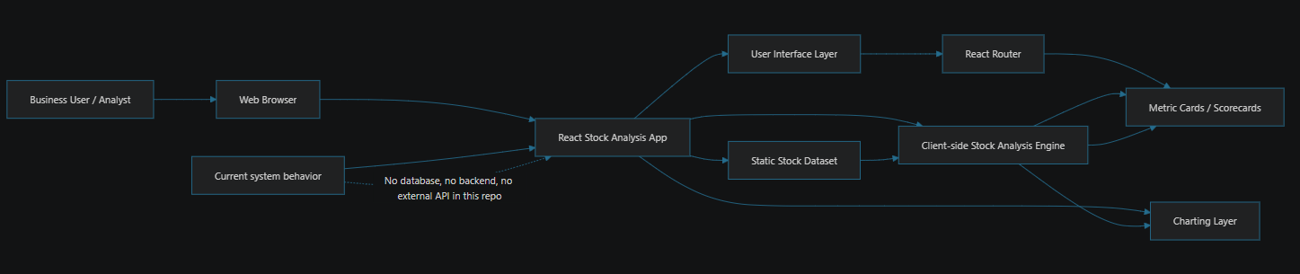

Architecture / service diagram
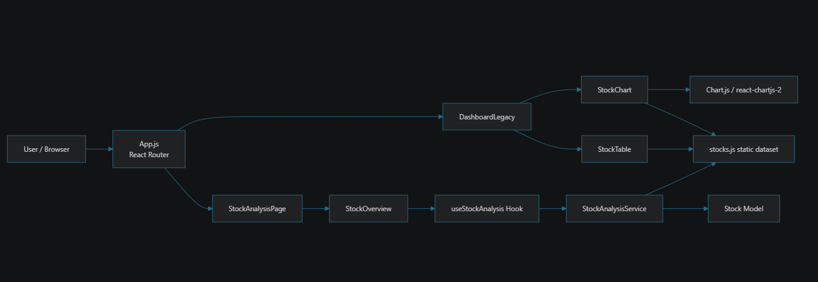
This shows the system as a client-side “service + model + UI” structure.
Interpretation
- Presentation layer: components
- Controller layer: custom hook
- Service layer: stock analysis service
- Domain model: Stock class
- Data source: static dataset

Sequence / data flow diagram
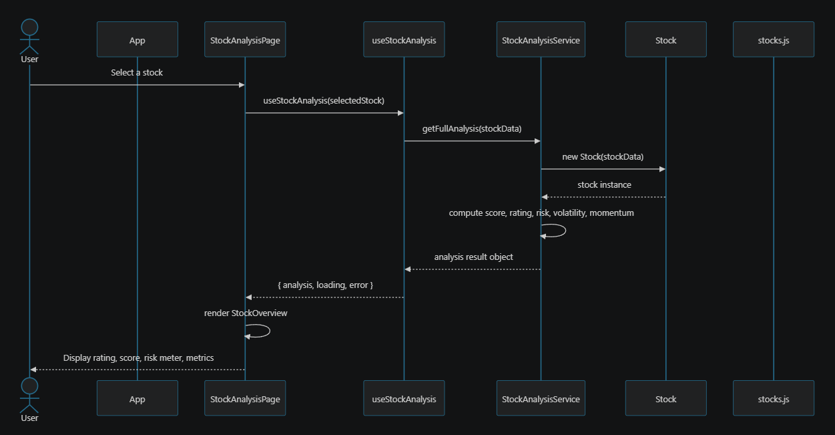
This is the main runtime path for stock analysis.
Data flow explanation
- User picks a stock.
- Component calls custom hook.
- Hook calls stock analysis service.
- Service creates a Stock instance.
- Service computes all business metrics.
- UI renders scorecards and charts.

Database ERD diagram
Since this project does not use a database, this is a conceptual ERD for the local data model.
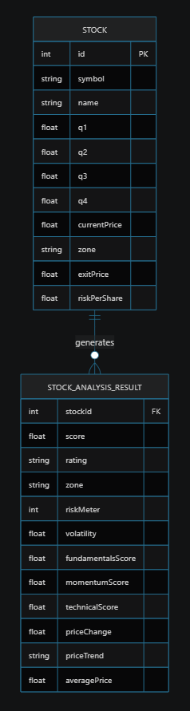
This captures the relationship between raw stock data and derived analysis output.
ERD note
This repo does not have a real database. This diagram reflects the conceptual model of:
- raw stock data
- derived analysis results

Algorithm diagram
The project’s core algorithm is a scoring model built on volatility, performance, and trend heuristics.
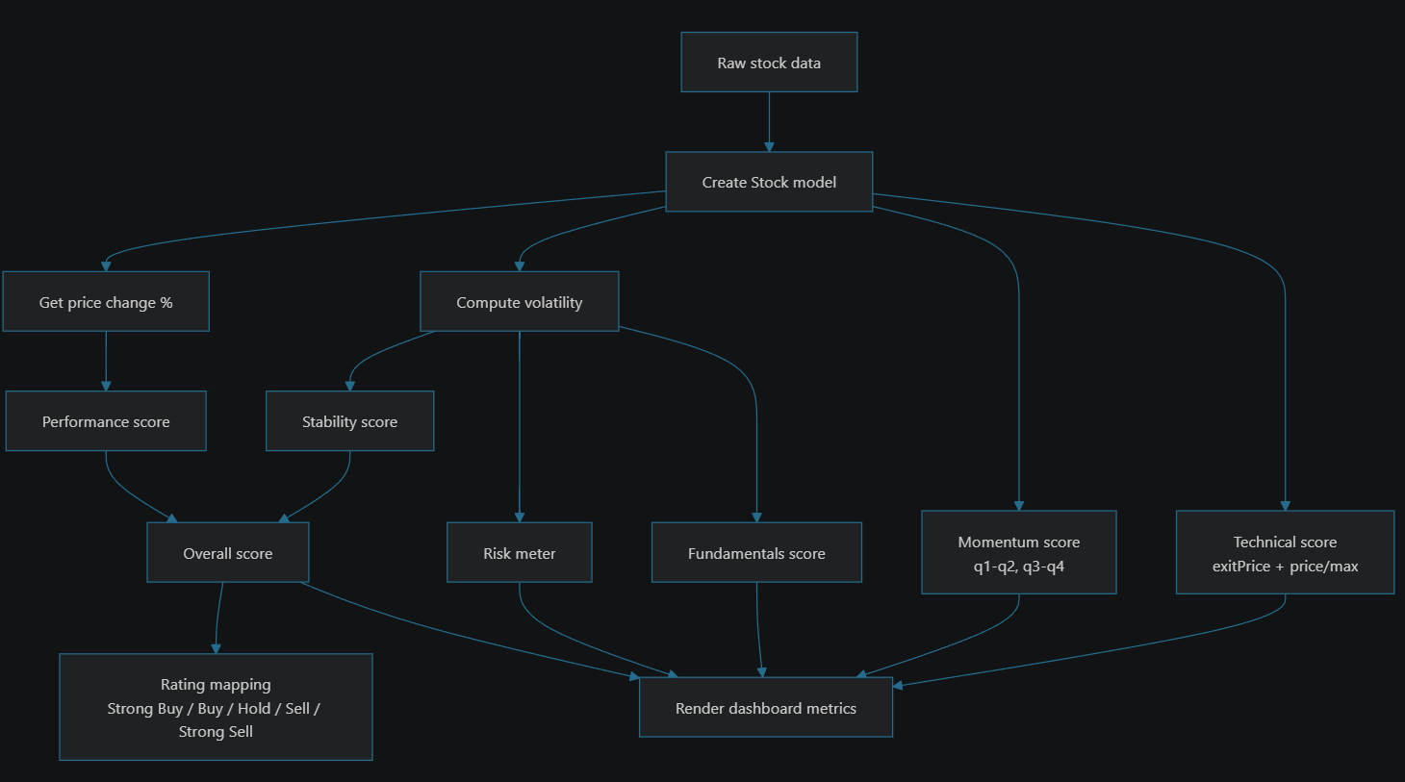
This is the logic implemented in StockAnalysisService.js.
Key algorithm idea
The app uses heuristic financial scoring:
- price change vs historical baseline
- volatility measurement
- momentum from quarterly movement
- technical signal using exit price and current price
- aggregated score and risk rating

API integration diagram
This project has no real API integration. It reads static JSON-like objects from stocks.js directly in the browser. It relies entirely on front-end static data and client-side calculations.
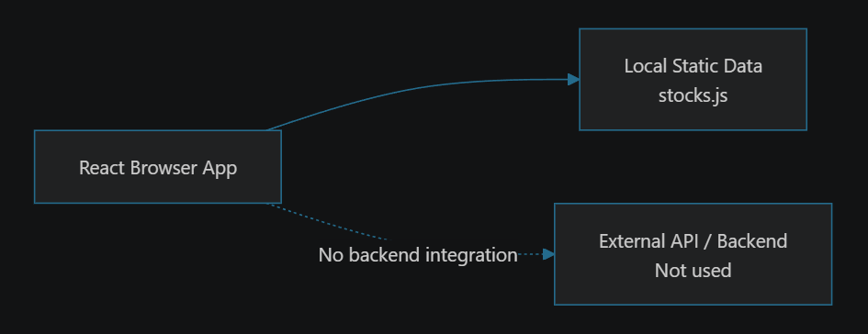
If this project were to become real-world, the next natural API layer would be something like:
- REST endpoint for stock list
- POST/GET for portfolio allocations
- maybe a real analytics backend
But that is not present in this repo.

Component hierarchy diagram
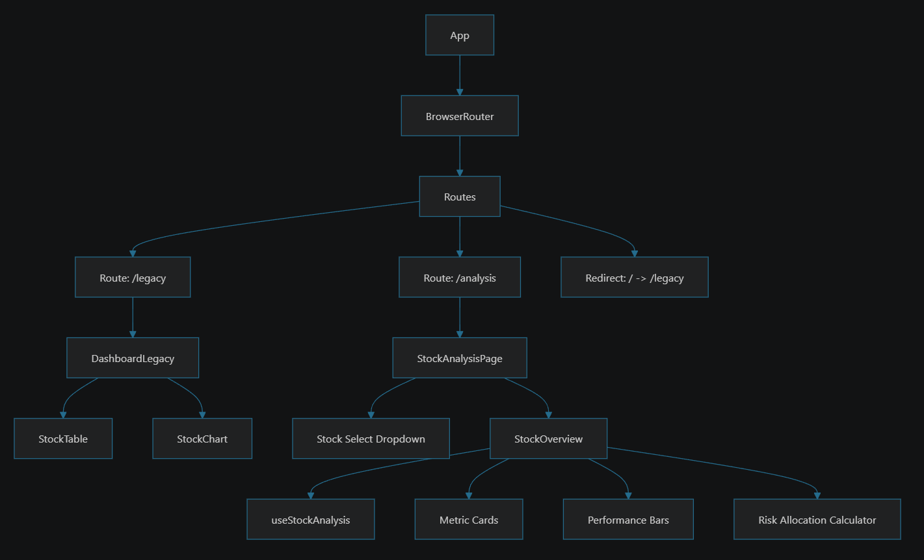
This diagram reflects the actual UI composition in App.js, DashboardLegacy.js, and StockAnalysisPage.js.
Component responsibilities
- App: router and route config
- DashboardLegacy: historical comparison dashboard
- StockTable: stock selection table
- StockChart: quarterly performance chart
- StockAnalysisPage: modern analysis page
- StockOverview: main analytical dashboard
- useStockAnalysis: state and service orchestration

Summary
This project is best described as:
- a static-data React SPA
- a stock metrics dashboard
- an educational demo of client-side architecture
- a front-end app with state, model, service, and UI separation
This project is a front-end stock intelligence demo built with React. It uses:
- static product data
- a domain model
- a stock analysis service
- custom hook orchestration
- interactive charts
- route-based view switching
The architecture is intentionally simple and educational rather than enterprise-scale. It is a good example of:
- component-driven UI
- layered frontend design
- client-side business logic
- data visualization

The architecture is simple and readable, but it is not production-grade for real financial data because:
- no backend or database
- no API integration
- static in-memory dataset
- heuristic algorithm, not a real trading or analytics engine
If you want, I can next generate:
- a more polished “system context diagram” for presentation use,
- a “clean architecture version” of the same project, or
- a PPT-ready version of these diagrams in a single page.

